**Commands used in R**

> setwd("C:/Users/Anu/Desktop")

> Xt <- read.csv("BreastCancer.csv")

> Xt

head(Xt)

Xt <- read.csv("Xt.csv",sep=",")

head(Xt)

#head means to see first 6 rows.

Yt <- Xt[Xt$Class == "malignant",c("Id","Cell.size")]

#To see Id and cell size of those whose Class is malignant.

Bt <- Xt[Xt$Class == "benign",c("X","Cl.thickness","Cell.size","Cell.shape","Marg.adhesion","Epith.c.size","Bare.nuclei","Bl.cromatin","Normal.nucleoli","Mitoses","Class")]

Mt <- Xt[Xt$Class == "malignant",c("X","Cl.thickness","Cell.size","Cell.shape","Marg.adhesion","Epith.c.size","Bare.nuclei","Bl.cromatin","Normal.nucleoli","Mitoses","Class")]

#We have divided the data into 2 sets. Benign (Bt) and Malignant (Mt)

hist(Bt$Cl.thickness, col="green", density =15, angle =45)

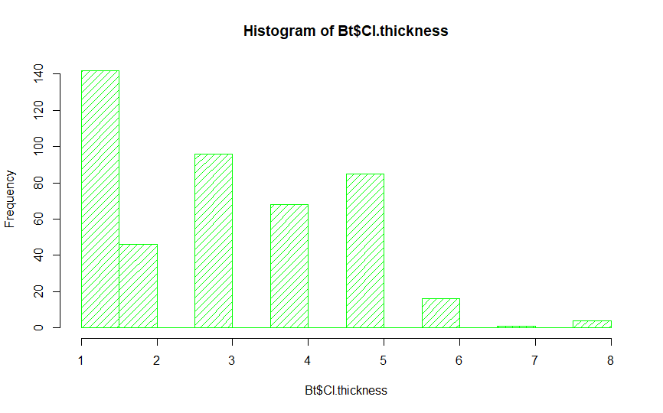

hist(Mt$Cl.thickness, col="red", density =15, angle =45)

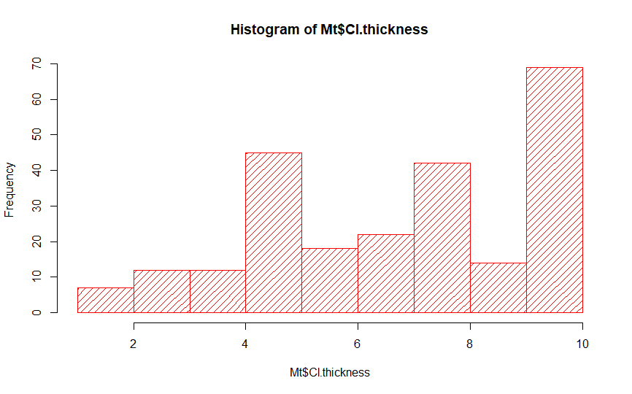

Interpretation

As the Cell Thickness increases, the chances that the Breast Cancer is Malignant increases and as the Cell Thickness decreases, the chances that that it is Benign, increases.

hist(Bt$Cell.size, col="green", density =15, angle =45)

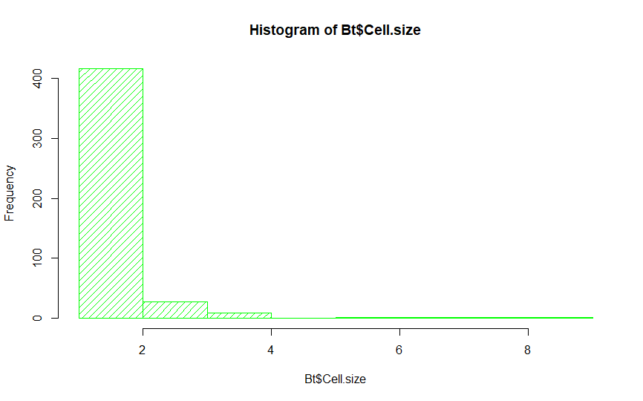

hist(Mt$Cell.size, col="red", density =15, angle =45)

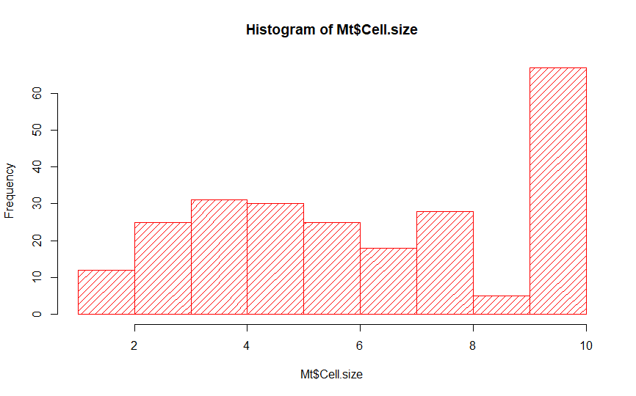

Interpretation

As the Cell size increases, the chances that the Breast Cancer is Malignant increases (highly) and as the Cell Thickness decreases, the chances that it is Benign, increases.

hist(Bt$Mitoses, col="green", density =15, angle =45)

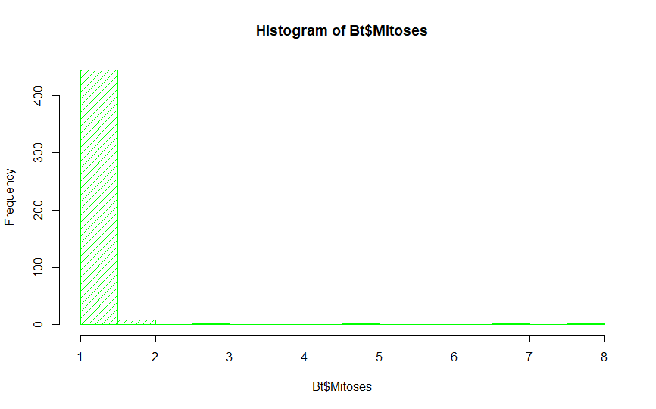

hist(Mt$Mitoses, col="red", density =15, angle =45)

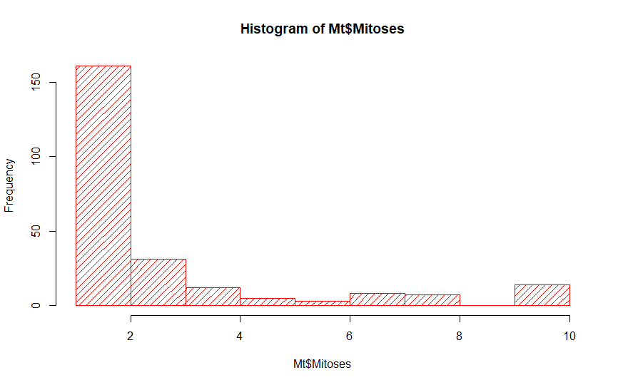

Interpretation

We cannot analyse whether the Breast Cancer is Benign or Malignant by seeing the number of Mitosis.